Drudgery reduction tool for women in agriculture

Women — whether young or old, healthy or sick — can be found across the developing world working long hours without rest. They pick tea, process tobacco, shell cotton pods, spread fertilizers on fields and transplant rice. In the developed world, machines usually do this work. But in poor countries, much of the labour is done by hand — and a woman's hand at that.
The nature of women's manual labour has changed little in many developing countries for centuries, either because technologies and innovations have not catered to their particular needs, or because they are inaccessible or unaffordable. Part of the problem, is that female agricultural labourers are an "invisible" workforce who see farm work as an extension of their family role, or are seen by others as unpaid assistants to their husbands.
Gender-friendly tools
Given the male-bias of tool-use, there is certain need to tailor technologies to meet the needs of female agricultural workers — and to make them cheap enough for women to access. These could include farm machines that take account of the different needs and capacities of women's bodies, catering to their typically lower mass and muscle strength, postural differences, load-bearing and lung-breathing capacity, and oxygen consumption rates.
Different Agri-implements proposed for drudgery reduction for women in agriculture
Hand Hoe
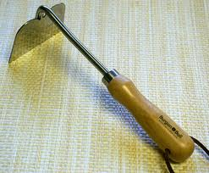
Hand weeder
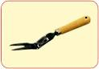
Improved sickle
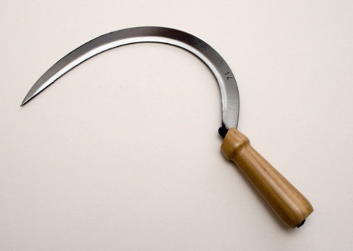
SRI- Weeder
